SDG indicator metadata
(Harmonized metadata template - format version 1.0)

0. Indicator information

0.a. Goal

Goal 10: Reduce inequality within and among countries

0.b. Target

Target 10.4: Adopt policies, especially fiscal, wage and social protection policies, and progressively achieve greater equality

0.c. Indicator

Indicator 10.4.2: Redistributive impact of fiscal policy

0.d. Series

Not applicable.

0.e. Metadata update

2021-02-05

0.f. Related indicators

The Impact of Fiscal Policy on Poverty (see Lustig, 2018, chapter 6).

0.g. International organisations(s) responsible for global monitoring

Institutional information: The World Bank Group is the official custodian for this indicator. This metadata documentation was developed and agreed by the three institutional data providers, CEQ Institute, OECD and The World Bank.

1. Data reporter

1.a. Organisation
The World Bank Group, Washington DC, USA; henceforth WBG.

2. Definition, concepts, and classifications

2.a. Definition and concepts
Definitions:
The Redistributive Impact of Fiscal Policy indicator is defined as the Gini Index of pre-fiscal per capita (or equivalized) income less the Gini Index of post-fiscal per capita (or equivalized) income. These terms are elaborated below and can be calculated with some different variations.
Concepts:
-Gini Index: a commonly used measure of inequality capturing the statistical dispersion in the distribution of income over a population (Gini, 1936). A Gini Index of zero expresses perfect equality: that is, every individual in the population has the same income. A Gini Index of 100 expresses maximum inequality: that is, all income accrues to a single individual, and all other individuals have zero income.
Household income: this can be calculated: (i) in per capita terms (household income divided by the number of household members); or (ii) in equivalized terms (household income divided by the square root of the number of household members). If a different definition is used, it should be noted in the reporting document.
-Pre-fiscal income: the cumulative income accruing to an individual (or a household) from market and private sources only. The Redistributive Impact of Fiscal Policy indicator can be estimated with reference to two different pre-fiscal income concepts depending on assumptions regarding the nature of the public, contributory old-age pension system (please also see the figure below, adapted from Lustig (2018) and in Lustig chapter 1, Section 2.2, pp. 20-29):
- Pre-fiscal income 1 - under the “pensions as deferred income” scenario: When incomes from public contributory old-age pension-system are counted as deferred market income and old-age pension-system contributions are counted as savings from current income (that is, the old-age pension system is treated as the equivalent of a mandatory savings program), pre-fiscal income is defined as an individual’s earned and unearned incomes from market and other private sources: wages, interest and dividend income; imputed income from owner-occupied housing and from consumption of own production; remittances; private transfers; old-age pension income from the public contributory pension system; and, less any contributions to the public old-age contributory pension system. In this case, the pre-fiscal income concept is called Market income plus pensions.

- Pre-fiscal income 2 - under the “pensions as government transfer” scenario: When incomes from current pension system are counted as a government transfer and old age pension system contributions are counted as a tax on current income, pre-fiscal income is defined as: wages, interest and dividend income; imputed income from owner-occupied housing and from consumption of own production; remittances; and private transfers only. In this case, the pre-fiscal income concept is called Market income.

When pensions are treated as pure government transfers, the redistributive effect of pensions may be exaggerated as retirees with zero or near zero pre-fiscal incomes will receive pension income that is – at least in part – income deferred when the individual was working. It is important to note that deferral of own income from one’s working years to one’s retired self is possible regardless of whether the pension system is actuarially fair and in both defined-contribution and defined-benefit pension plans. Treating the public contributory pension system income as pure deferred income, however, does not allow us to capture any portion of the redistributive effect of pensions which may in effect exist. Therefore, we view the pensions as government transfer and pensions as deferred income scenarios as imperfect upper and lower bound estimates (respectively) of the true redistributive effect of contributory pensions. Rather than generating estimates of the redistributive effect of fiscal policy under specific assumptions about public contributory pension system income, the OECD instead reports estimates of the redistributive effect for the population under 65 years of age (while treating contributions to the public contributory pension system as a tax). This is most comparable to the “pensions as deferred income” scenario, although not exactly the same.
-Post-fiscal income: The Redistributive Impact of Fiscal Policy indicator can be estimated with reference to two different post-fiscal income concepts, Disposable Income and Consumable Income. The most comprehensive concept is that of Consumable Income, which incorporates not only the impact of direct taxes and transfers but also of indirect taxes and price subsidies.
Disposable and Consumable Income are equal in value under the “pensions as deferred income” and “pensions as government transfer” scenarios. However, they are derived from pre-fiscal income 1 and pre-fiscal income 2 differently; please see the figure below, adapted from Lustig (2018):
- Post-fiscal incomes under the “pensions as deferred income” scenario:

Post-fiscal Income A - Disposable Income: pre-fiscal income less direct taxes paid and less social insurance contributions made to the public fiscal authority plus direct cash transfers and the monetary value of benefits (measured at what governments spend) received by households in the form of near-cash transfers (e.g., food stamps, school breakfasts, school uniforms).
Post-fiscal Income B - Consumable Income: pre-fiscal income less direct and indirect taxes paid and less social insurance contributions other than for old-age pensions made to the public fiscal authority plus direct cash transfers and the monetary value of benefits (measured at what governments spend) received by households in the form of near-cash transfers (e.g., food stamps, school breakfasts, school and indirect price subsidies.
- Post-fiscal incomes under the “pensions as government transfer” scenario:

Post-fiscal Income A - Disposable Income: pre-fiscal income less direct taxes paid and less social insurance contributions and less contributory old-age pension contributions made to the public fiscal authority plus direct cash transfers and the monetary value of benefits (measured at what governments spend) received by households in the form of near-cash transfers (e.g., food stamps, school breakfasts, school uniforms).
Post-fiscal Income B - Consumable Income: pre-fiscal income less direct and indirect taxes paid and less social insurance contributions and less contributory old-age pension contributions made to the public fiscal authority plus direct cash transfers and the monetary value of benefits (measured at what governments spend) received by households in the form of near-cash transfers (e.g., food stamps, school breakfasts, school uniforms), and plus indirect price subsidies.

CEQ Income Concepts
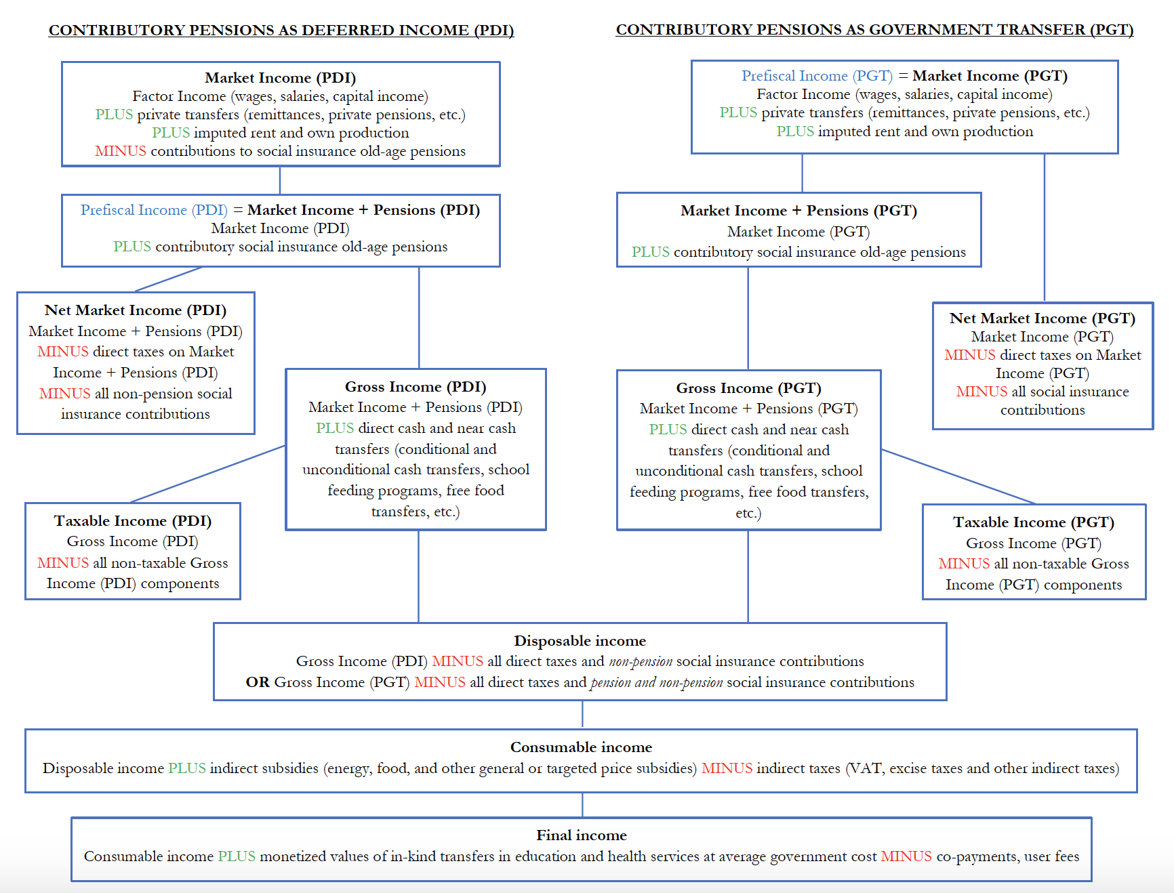
Source: adapted from Lustig (2018).

2.b. Unit of measure
- Gini Index points: The Redistributive Impact of Fiscal Policy indicator is the difference between pre-fiscal Gini Index and the post-fiscal Gini Index. Thus, if a simple difference is applied the measure is the change in Gini Index points.

2.c. Classifications
Not Applicable

3. Data source type and data collection method

3.a. Data sources
The Redistributive Impact of Fiscal Policy indicator is constructed from a range of data sources using a standardized methodology as outlined in Lustig, 2018. To construct this indicator requires a nationally representative micro-data set (a Household Budget Survey, for example, or an Income and Expenditure Survey) and fiscal or budgetary or administrative data on revenue collections, social expenditures, and expenditures on consumption subsidies. The data sources employed at the country level are detailed in the country-specific footnotes.

3.b. Data collection method
Nationally representative micro-data sets are often collected and hosted by the national statistics agency. However, access to such data sets is frequently given to a different part of the administration (the Ministry of Finance, for example, or the Ministry of Development and Planning). Fiscal or budgetary or administrative data is occasionally available in unabridged summaries with enough detail at the program or policy level for the estimation of the indicator. More often, however, budgetary and administrative data is kept by the agency executing the program (so, for example, the Ministry of Education will keep data on its own fiscal-year expenditures). These datasets are then used to construct the Redistributive Impact of Fiscal Policy indicator.

3.c. Data collection calendar
Source data collection follows the update cycle for country-specific micro-data sets as well as the audit cycle for fiscal year revenues and expenditures. The final constructed SDG indicator relies upon the calendar of the source data collection as well as availability of analytical capacity by the data compilers (see below).

3.d. Data release calendar
A biannual update to the SDG database will be made by the custodians, but it is expected that most countries will have updated indicators only every five years or so, given the underlying source data collection calendars. The WBG would be the custodian of any international agreement committing individual countries to an update schedule. Existing CEQ Assessments listed here: commitmentoequity.org/publications-ceqworkingpapers/

3.e. Data providers
Ultimately the data providers are national-level statistical agencies for the micro-data sets and national-level fiscal agencies and bodies for budgetary and administrative data. Most OECD countries also calculate their own pre- and post-fiscal Ginis. That is, they directly calculate the 10.4.2 indicator. These are collated by the OECD and will be sent directly to the World Bank as custodians.

Where a country produces its own 10.4.2 indicator it will take precedence over estimates produced by other institutions, subject to meeting the reporting requirements below. For all other countries, estimates and indicators produced by the WBG and/or the Commitment to Equity Institute will be considered.

3.f. Data compilers
There will be three main data compilers: the WBG, the Commitment to Equity Institute and the OECD. Data compilers will be responsible for compiling the necessary information and documentation in ways that are compliant with the posting requirements described as follows:
- The WBG will compile information all Commitment to Equity Assessments conducted by WBG teams and by (non-OECD) national participants working independently. The focus of this exercise will be on assessments conducted in or after 2015.
- The Commitment to Equity Institute will compile information on all Commitment to Equity Assessments conducted by the Institute. The Institute’s submissions to the WBG will include information on pre-fiscal and post-fiscal Gini Indices, information needed to complete the necessary metadata (when available) and do-files needed for replication (when available).
- The OECD will compile information on all fiscal assessments conducted by OECD national participants. The OECD’s submissions to the WBG will include information on pre-fiscal and post-fiscal Gini Indices.

The three data compilers will meet periodically to review the reporting and submission process, exchange information on (new) methodological changes, and coordinate on further methodological innovations regarding the Commitment to Equity Assessment as needed.

3.g. Institutional mandate
The WBG has the mandate to measure, harmonize, disseminate and produce international poverty numbers and inequality. These are the two key headline SDG measures which also underpin the CEQ analysis.

4. Other methodological considerations

4.a. Rationale
Developed by the Commitment to Equity Institute (CEQ) at Tulane University, the Redistributive Impact of Fiscal Policy indicator demonstrates in an accounting framework the total amount by which current income inequality is reduced or increased by the current execution of fiscal policy (including direct and indirect taxes; social insurance and old-age pension contributions; direct cash or near-cash transfers; and subsidies). For example, if the Redistributive Impact of Fiscal Policy is positive, that indicates that the net effect of Fiscal Policy is to reduce the Gini index from what it otherwise would be without Fiscal Policy (in an accounting sense, not as an economic counterfactual). The indicator allows policy makers and the broader stakeholder and advocacy communities to systematically track progress at the country level in the contribution of fiscal policy to more equitable societies.

4.b. Comment and limitations
Reporting on assumptions: The choice of whether to report the Redistributive Impact of Fiscal Policy indicator under the pensions as deferred income or pensions as transfers scenario will be left to the country authority or international agency in charge of submitting this indicator, but the choice must be clearly indicated in the reporting document. For countries for which the data exist, pre-fiscal and post-fiscal inequality should be calculated for both pension scenarios, and the default included in the SDGs database is pension as deferred income. If only data treating pensions as transfers are available, it is recommended to report them only for the working age population (under 65 years of age). Some authorities may also choose to use equivalized income instead of per capita income as the welfare indicator. This too should be clearly indicated in the reporting document. Last, some authorities may report these data based on a micro-data set using income or expenditure as the relevant welfare concept. Once these decisions are taken, they should be maintained in subsequent years in order to assure comparability, except that all countries are encouraged to provide data with pension as deferred income. The data reported in the UN Global Database try, to the extent possible, to distinguish between the different concepts used for different countries.
Feasibility: The Redistributive Impact of Fiscal Policy indicator can be estimated for any country with a micro-data set detailing incomes or expenditures (or both) at the household or individual level and with a set of fiscal, administrative, or budgetary records detailing public expenditures at the program level and revenue collections at the revenue-collection instrument level.
Suitability/Relevance: The Redistributive Impact of Fiscal Policy indicator provides a direct estimate of the current impact of fiscal policy on redistribution (of incomes). It therefore provides a direct estimate of progress on SDG Target 10.4: “Adopt policies, especially fiscal, wage and social protection policies, and progressively achieve greater equality.”
Limitations: The Redistributive Impact of Fiscal Policy indicator does not address wage policy. It does not include the benefits of public provision of in-kind benefits, such as health, education, sanitation and housing services, which may have both present-day and longer-term impacts on present-day and future inequality.

4.c. Method of computation
Pre-fiscal income can be derived from a nationally-representative micro-data set (an Income and Expenditure Survey, for example). Post-fiscal income is estimated via the allocation of the tax burdens and the expenditure-based benefits that stem from fiscal policy (direct and indirect taxes, social contributions, direct cash and near-cash transfers, subsidies, et cetera). Procedures for constructing pre-fiscal and post-fiscal income concepts and estimating their distribution from an underlying microdata set are detailed comprehensively in Lustig (2018) (Chapters 1, 6, and 7).
The Gini Index is calculated rescaling the Gini Coefficient by a factor of 100. The Gini Coefficient is calculated according to standard formulas for a (generalized) Gini Coefficient. See, for example, Duclos and Araar (2006):
$$GINI Index=100 x GINI \left(Χ;υ\right)$$

where X is a random variable of interest with mean μ(X), F(X) is its cumulative distribution function, υ is a parameter tuning the degree of ‘aversion to inequality’. The standard Gini corresponds to υ = 2. Cov is a Covariance estimate.

4.d. Validation
The validation process would require consultation with line ministries and agencies responsible for executing programmatic expenditures or revenue collections.

4.e. Adjustments
Not – applicable.

4.f. Treatment of missing values (i) at country level and (ii) at regional level
• At country level
When a nationally representative micro-data set and/or country-level fiscal, budgetary, and administrative data are not available, the indicator cannot be generated. Budget and administrative data exists for every fiscal system but is not always public.

• At regional and global levels
Currently no regional or global aggregates exist for this indicator.

4.g. Regional aggregations
Currently no regional or global aggregates exist for this indicator.

4.h. Methods and guidance available to countries for the compilation of the data at the national level
A complete description of the methodology, recommendations, and guidelines behind the generation of the Redistributive Impact of Fiscal Policy indicator can be found in Chapters 1, 6, 7, 8 and Part IV in Lustig (2018).
This indicator can be calculated based on the current state of household surveys micro-data and budget administrative data.

4.i. Quality management
The World Bank as custodian will coordinate with data compilers on the quality of their respective country indicators. The WBG will verify the quality of the SDG 10.4.2 indicators produced by WBG.

4.j Quality assurance
In its role as custodian agency of the proposed indicator for SDG 10.4, the World Bank Group is responsible for quality control of and quality assurance over all data submitted to the SDG Indicators Database, as well as the underlying analysis and documentation.
In practice and taking advantage of the proposed partnership between the WBG and the Commitment to Equity Institute at Tulane University regarding the monitoring of the proposed indicator, the Institute will be responsible for quality control of and quality assurance over the Redistributive Impact of Fiscal Policy indicators submitted by the Institute. Similarly, the OECD will be responsible for quality control of and quality assurance over the Redistributive Impact of Fiscal Policy indicators submitted by OECD member nations.
For any data reporting outside of the CEQ Institute and OECD, the World Bank will review accompanying technical documentation to confirm that the methodology employed is consistent with that described in Lustig (2018). Where questions arise, the World Bank will engage with the reporting institution to verify the analysis.

4.k Quality assessment
Reporting requirements:
The WBG will only submit information to the SDG Indicator Database on those Commitment to Equity Assessments meeting the following requirements:
- Information on both pre-fiscal and post-fiscal Gini is available
- Complete metadata is available
- Technical report on methodology is available
- Master Workbook or equivalent is available

While initially reporting requirements contemplate that the post-fiscal Gini is reported for either Consumable or Disposable Income, countries and international agencies are encouraged to report both whenever possible. When this is not feasible in the short term, they should work towards reporting both indicators over time.
WBG submissions to the SDG Indicator Database will indicate whether information has been prepared by the WBG, the Commitment to Equity Institute, or another agency (e.g. OECD for OECD countries).
Required metadata include:
- Welfare aggregate: consumption or income
- Welfare aggregate: per capita or equivalized
- Treatment of pensions: pensions as deferred incomes or government transfers
- Population coverage: all or working age
- Indirect effects of indirect taxes and subsidies included: YES/NO
- Level of government: general or consolidated; federal or federal plus subnational
- Alternative market income Gini using (PTT/PDI, whichever is not one of the main indicators), where available
- Date of household survey
- Date of submission
- Link to official report and technical documentation
- Reporting institution and contact person

5. Data availability and disaggregation
As of February 2021, the Redistributive Impact of Fiscal Policy indicator is available from the Commitment to Equity Institute and the World Bank and for at least one year in 78 countries across the following regions:
- East Asia and the Pacific: 11
- Europe and Central Asia: 38
- Latin America and the Caribbean: 10
- Middle East and North Africa: 3
- North America: 2
- East Asia Pacific: 11
- Sub-Saharan Africa: 14

The indicator is available for 34 of the 37 OECD member countries for Pre-fiscal and Disposable Income only. Data are available annually (with the exception of countries whose income survey is fielded every two or three years) through the OECD Income Distribution Database.
Time series:
The Redistributive Impact of Fiscal Policy indicator is currently for the most part available for single country/year pairs only. The main limitation to producing more frequent time series is the availability of more frequent household surveys. However, that is also a limitation faced by other SDG indicators.
Disaggregation:
The Redistributive Impact of Fiscal Policy indicator can be shown separately for as many different subgroups as are represented in the survey or micro-data from which it is drawn: income subgroups; by gender, age group, ethnic grouping; geographic location; disability status, household size; household dependency ratios, and so on. These are frequently reported in the main CEQ studies which the SDG indicators are drawn from but not reported within the SG database itself.

6. Comparability / deviation from international standards
Sources of discrepancies:
Not applicable.

7. References and Documentation
Duclos, Jean Yves, and Abdelkrim Araar. 2006. Poverty and Equity: Measurement, Policy, and Estimation with DAD. Springer US.
Gini, Corrado. (1936). "On the Measure of Concentration with Special Reference to Income and Statistics", Colorado College Publication, General Series No. 208, 73–79.
Lustig, Nora (ed). 2018. CEQ Handbook: Estimating the Impact of Fiscal Policy on Inequality and Poverty, CEQ Institute at Tulane University and Brookings Institution Press. commitmentoequity.org/publications-ceq-handbook (open source; available online free of charge).

The Gini Coefficient is the same indicator but measured between 0 and 1 as a proportion rather than a percentage.
Other equivalence scales exist but this is the one used by OECD countries in generating this SDG indicator.
Some of the income items mentioned may not be part of the income definition used by various NSOs and IGOS, with imputed rents or consumption of own production being a case in point.

